# **Angular Assignment**

## **Use Case**

Create a Covid tracking app in Angular.

## **Modules Identified**

1. **App Module:** This is the main module which gets loaded first along with its dependencies when the app starts.
2. **Dashboard Module:** It is responsible for declaring the Dashboard, Latest news, and Precautions Components and providing the dependencies.
3. **Admin Module:** It is responsible for declaring the Login, Admin Dashboard, and Add News Components and providing the dependencies.
4. **Shared Material Module:** It is responsible for declaring the Header Component and importing various Angular Material Modules, which are used across the app.
5. **Page Not Found Module:** It is responsible for declaring the Page Not Found Component and providing the dependencies.

## **Components Identified**

1. **App Component:** This is the main component of the app, which gets rendered first in the index.html file.
2. **Dashboard Component:** It renders the Covid19 Data of states and district from External APIs.
3. **Latest News Component:** It Renders the latest news that is posted by the admin. I am using Fake JSON Server to fetch and save the news.
4. **Precautions Component:** It Renders a static page which displays various precautions related to Covid19.
5. **Login Component:** It renders a login page for admin users. Fake JSON server is used to store various admin credentials.
6. **Admin Dashboard Component:** It renders all the news that are added by admin and provide an option to delete the news.
7. **Add News Component:** It renders a form to give admin user the ability to add news for the Latest News Section.
8. **Header Component:** It is responsible for providing routing abilities to move from one page to another.
9. **Page Not Found Component:** This component is rendered whenever the URL entered does not matches with any defined route.

## **Services Identified**

1. **User Service:** Provides Services to login component to facilitate user validation.
2. **Dashboard Service:** It is used to fetch Covid19 data from external APIs, and some filtering tasks based on user requests.
3. **Latest News Service:** Contains APIs for saving, deleting and fetching News Data from Fake JSON Server.

## **Routing Modules Identified**

1. **App Routing Module:** This is the main routing module which specifies various paths and the child routes, and their guards.
2. **Admin Routing Module:** It defines various child routes which can be accessed by admin user only after logging into application.
3. **Dashboard Routing Module:** It defines various child routes which are linked to displaying data to normal user.

## **Route Guards Used**

1. **Login Can Activate Guard:** This guard prevents a logged in user to go to Login page again.
2. **Dashboard Can Activate Guard:** This guard prevents non-logged in users to access pages that are meant for admin use only.

## **GitHub Link**

<https://github.com/yankit-chauhan/NAGP-Angular.git>

## **Working Application Link**

<https://yankit-chauhan.github.io/NAGP-Angular/>

Website is working but as I was unable to deploy Fake JSON server, some pages won’t work.

## **Admin Login Credentials**

Username : admin

Password: nimda

## **Screenshots**

**Dashboard:**

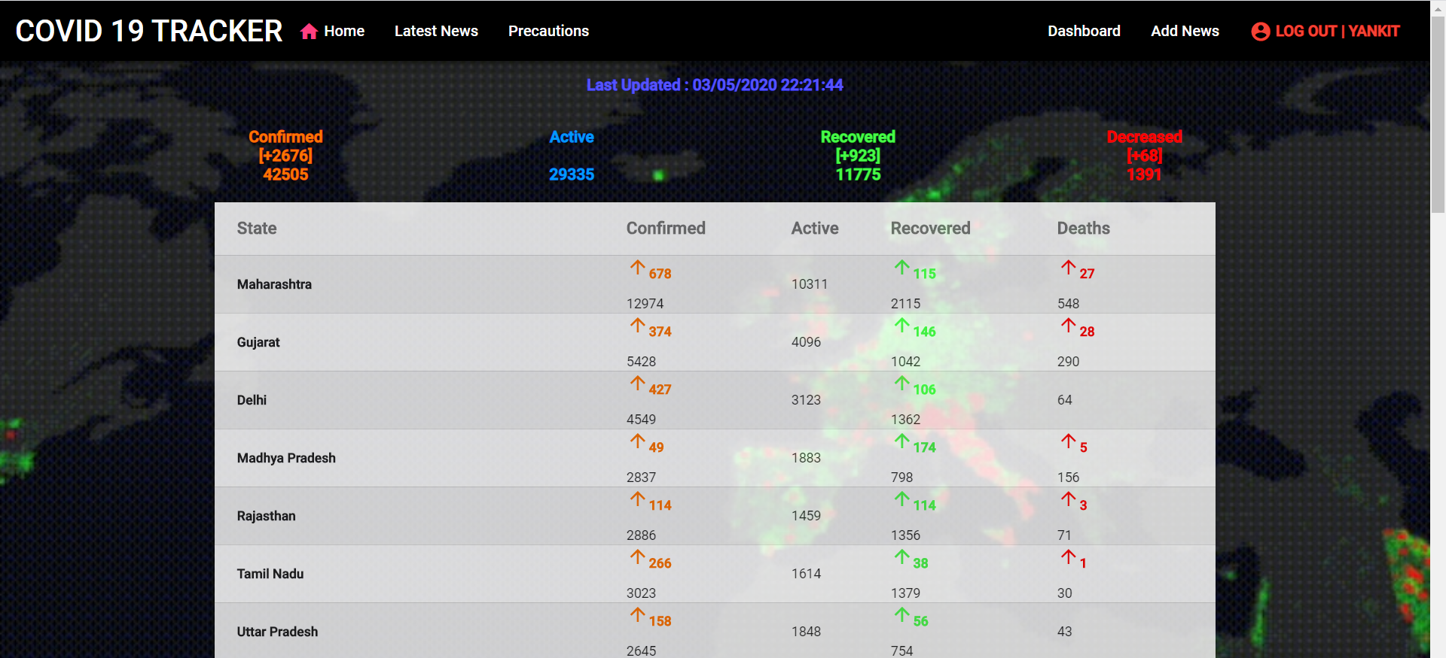

**Latest News:**

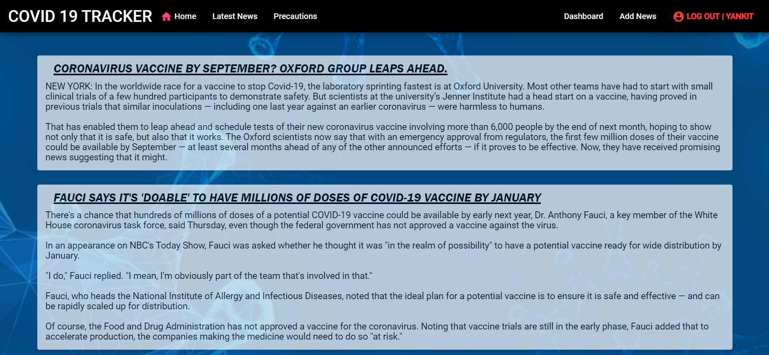

**Precautions:**

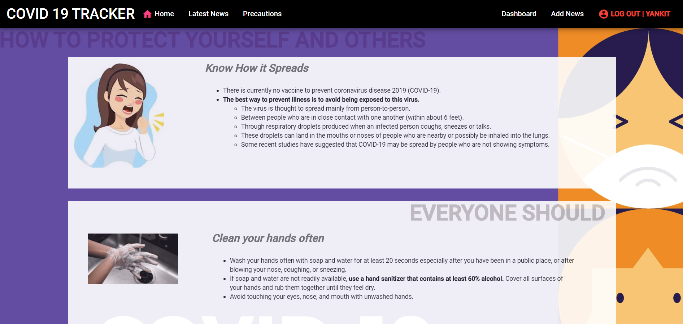

**Admin Login:**

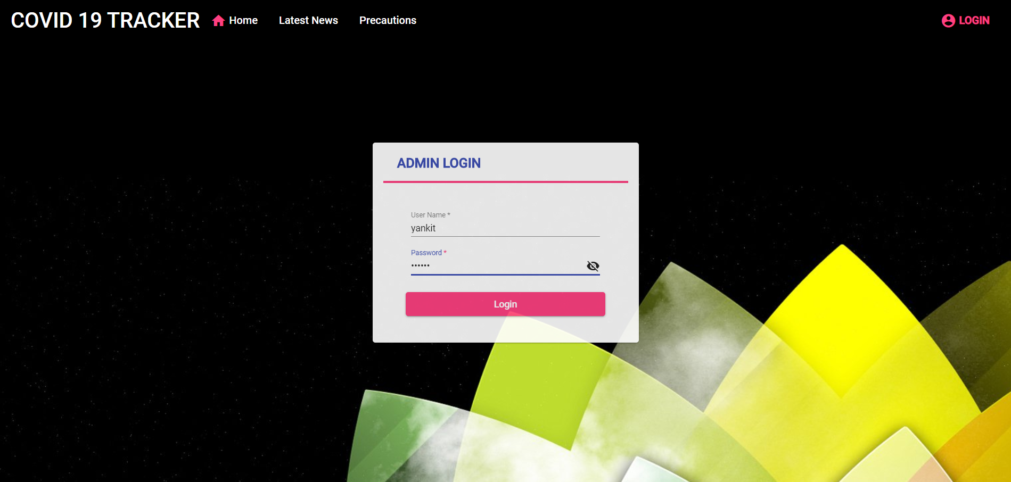

**Admin Dashboard:**

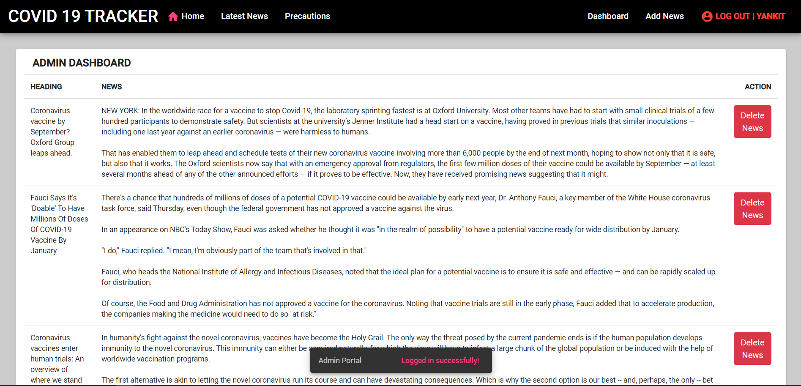

**Add News:**

